NAME:P.SAI
  - 2303A52395, B43
  - ASSIGNMENT:14.1

  - Task-1- Portfolio Website Design You are building a personal portfolio website to showcase your
  - work. Requirements: • Create sections for About Me, Projects, and Contact.
  - • Use AI to: o Suggest color palettes and typography.
  - o Create a responsive layout with Grid/Flexbox.
  - o Add smooth scrolling navigation.

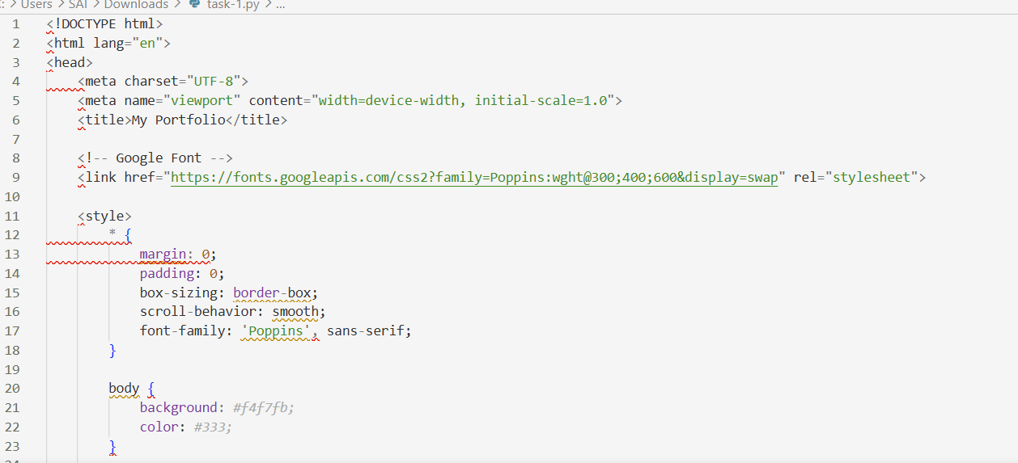

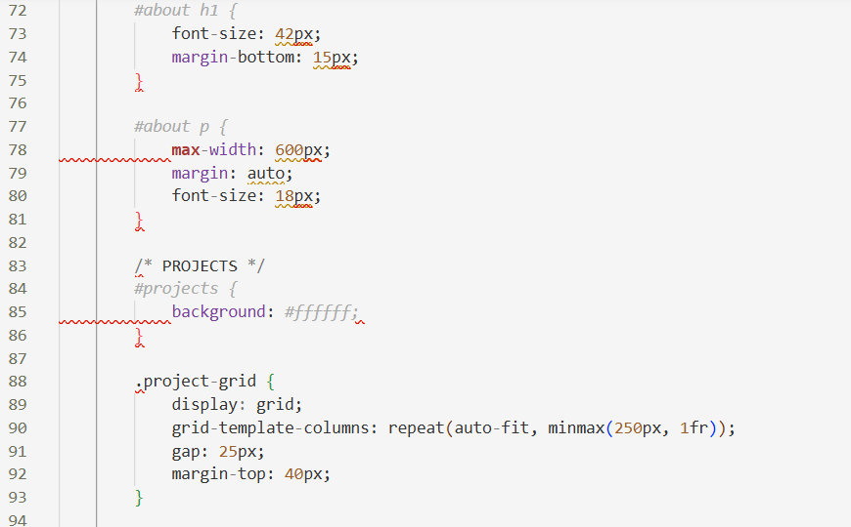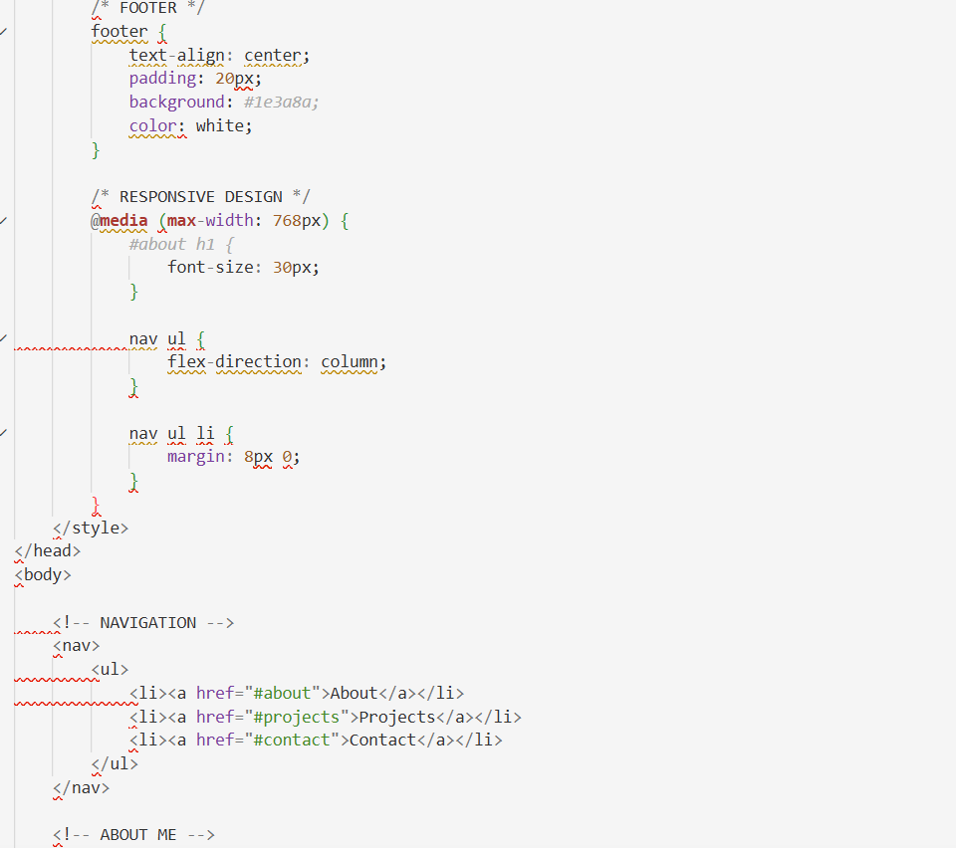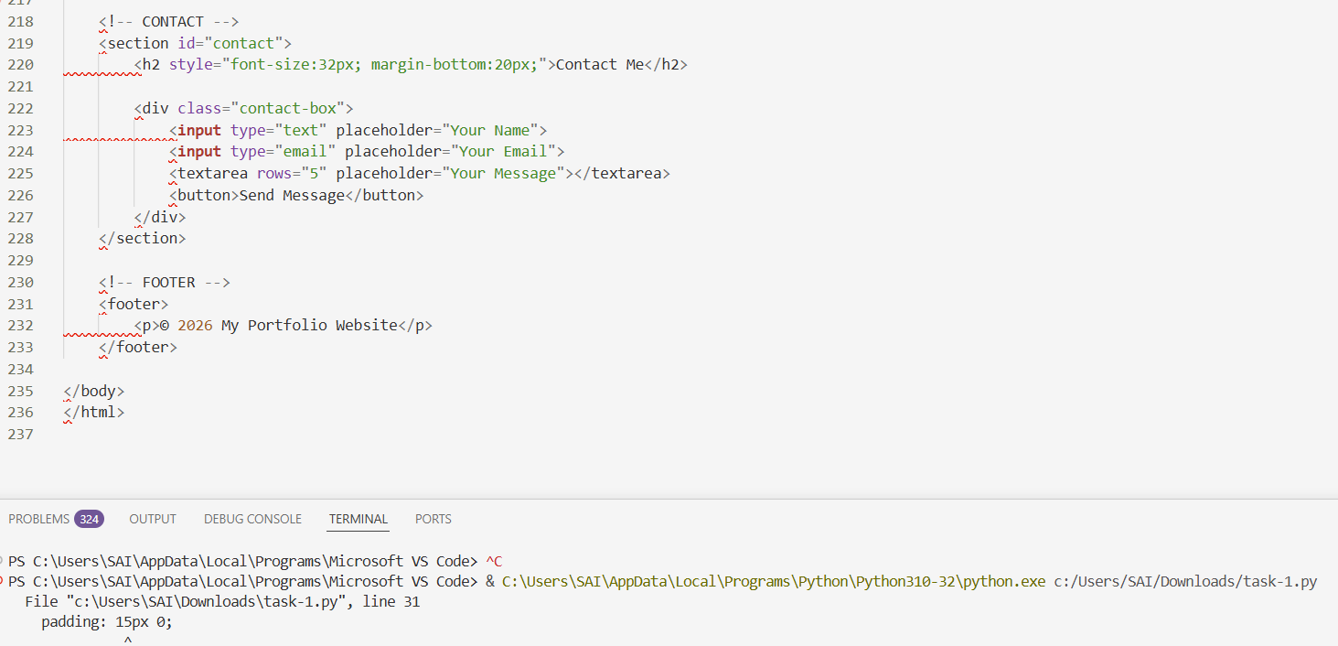
OUTPUT
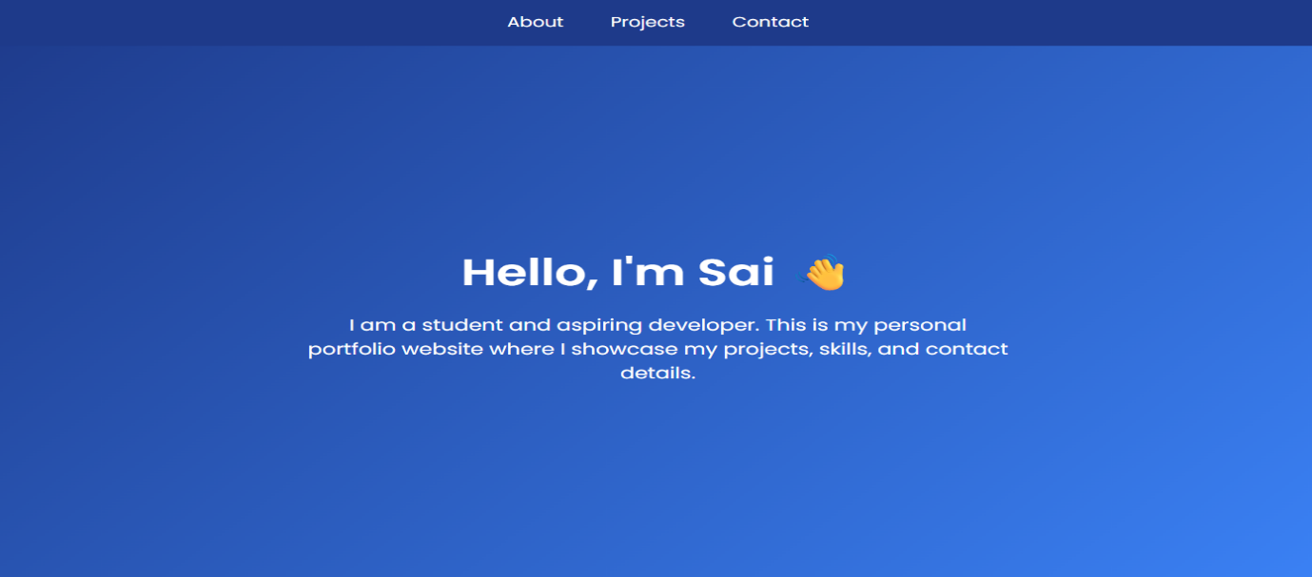

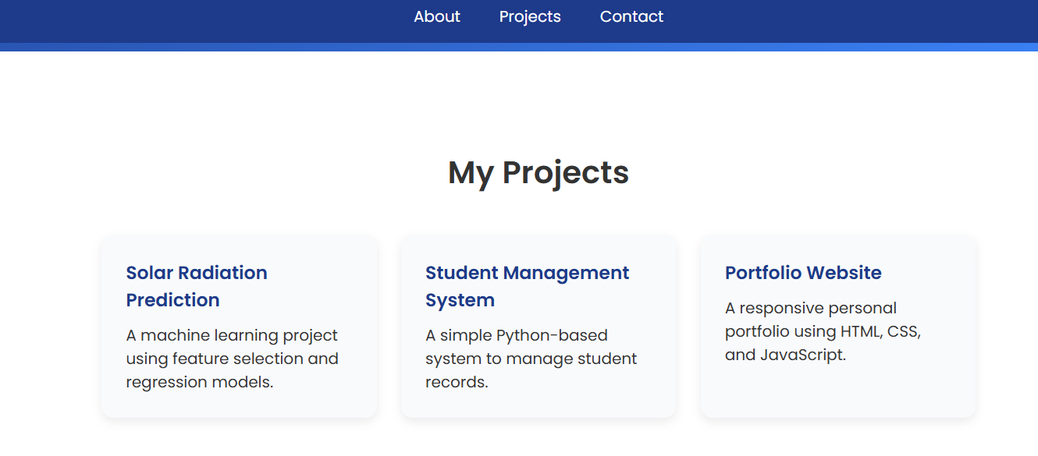
  - Observation: This task focuses on designing a personal portfolio website using AI assistance. The website includes three main sections: About Me, Projects, and Contact. AI was used to suggest a modern color palette, typography (Poppins font), and a responsive layout using CSS Grid and Flexbox. Smooth scrolling navigation was also implemented to improve user experience.

  - Task 2 – Online Store Product Page Design a product display page for an online store.
  - Requirements:
  - • Display product image, title, price, and "Add to Cart" button.
  - • Use AI to: o Style with BEM methodology. o Make layout responsive.
  - o Add hover effects and "Add to Cart" alert
  - CODE:
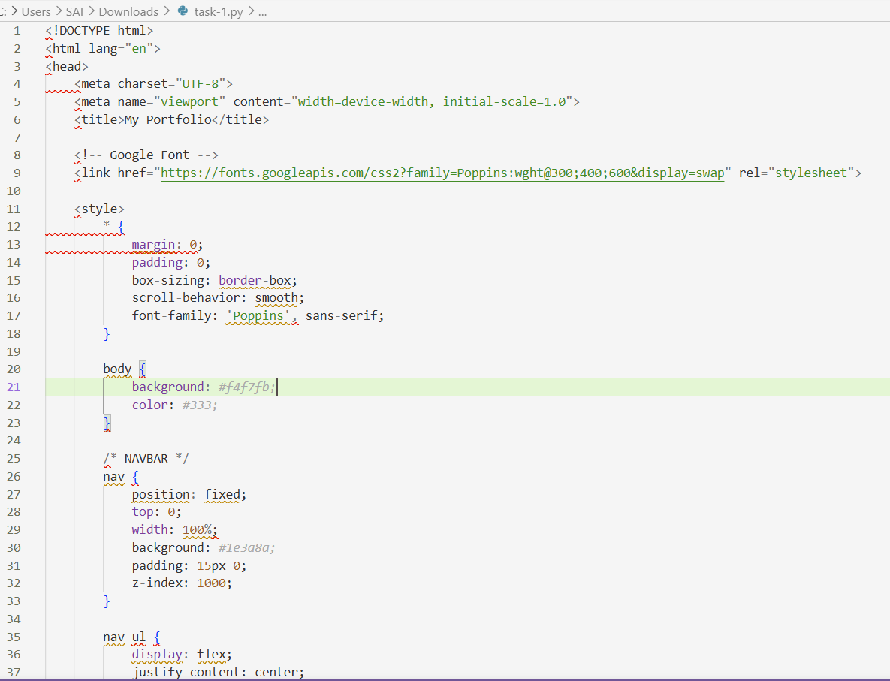

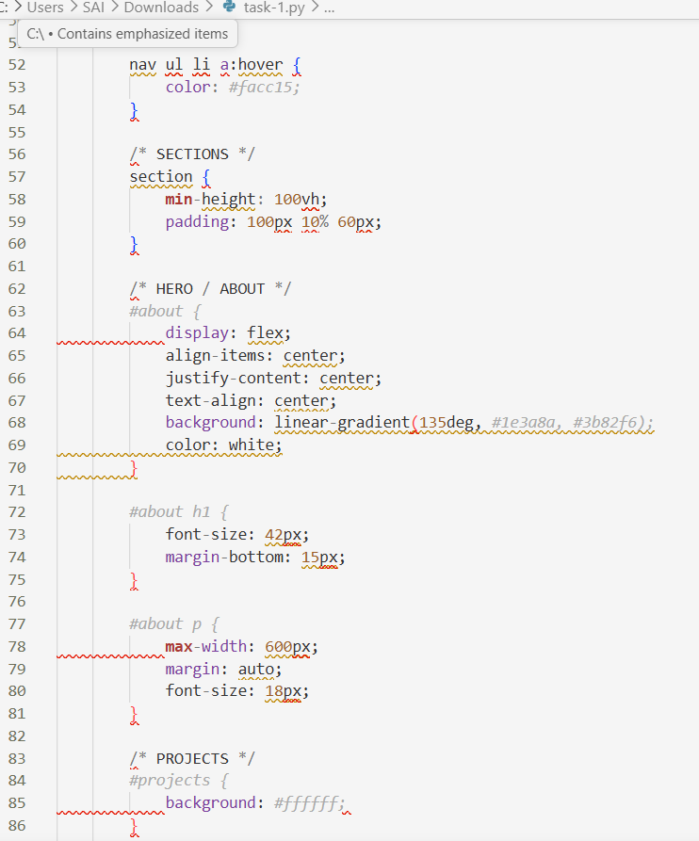
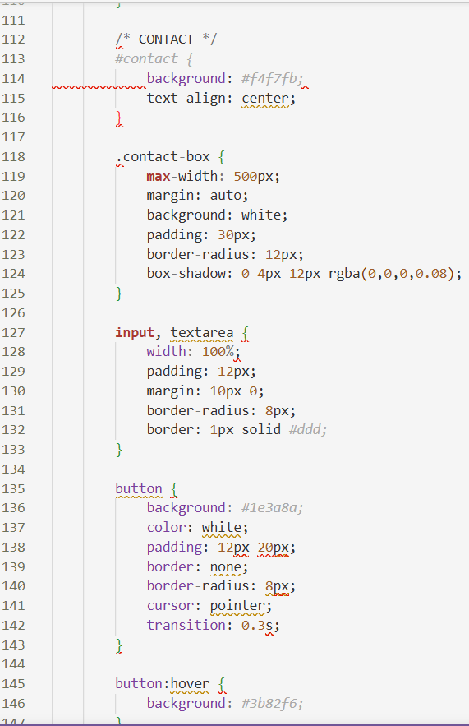
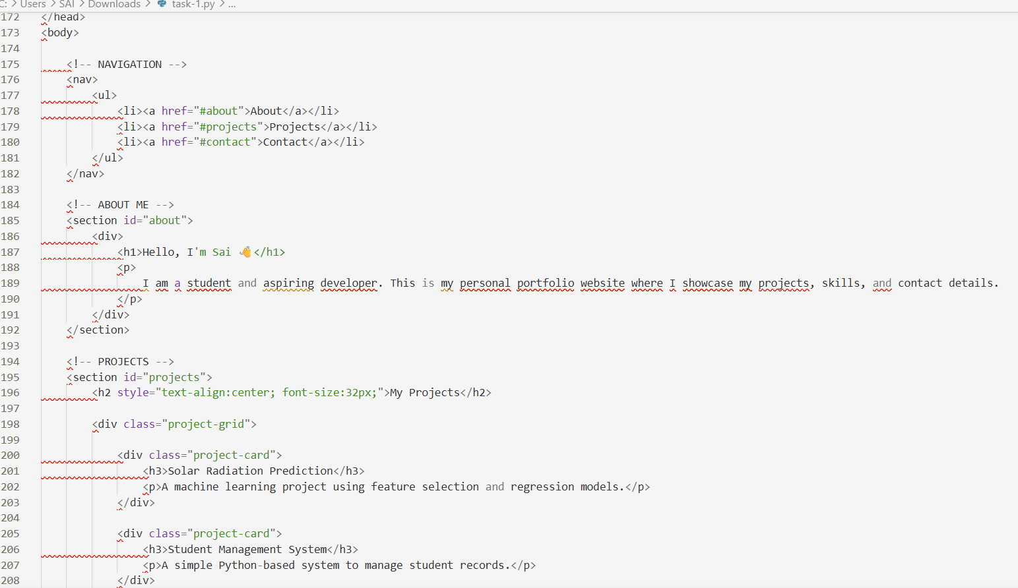
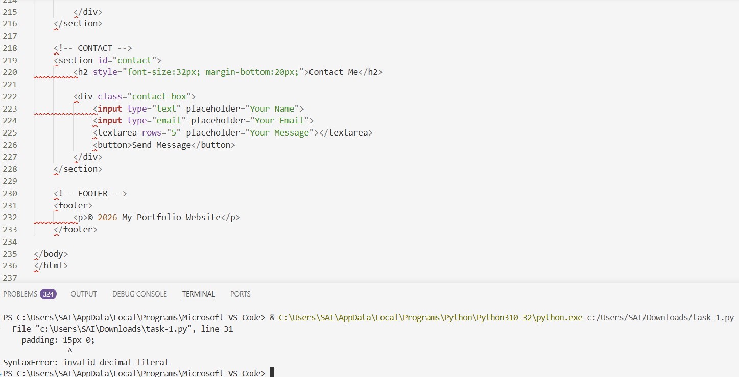

Output
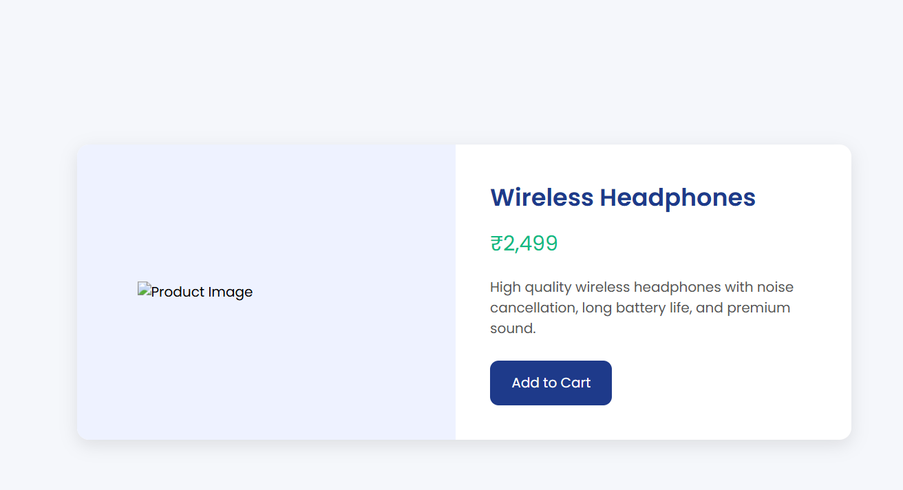

  - Task 3 – Event Registration Form Build an event registration form for a conference.
  - Requirements:
  - • Collect name, email, phone number, and session selection.
  - • Use AI to: o Add form validation with JavaScript.
  - o Make the form accessible with labels and ARIA. o Style with a professional look
  - CODE
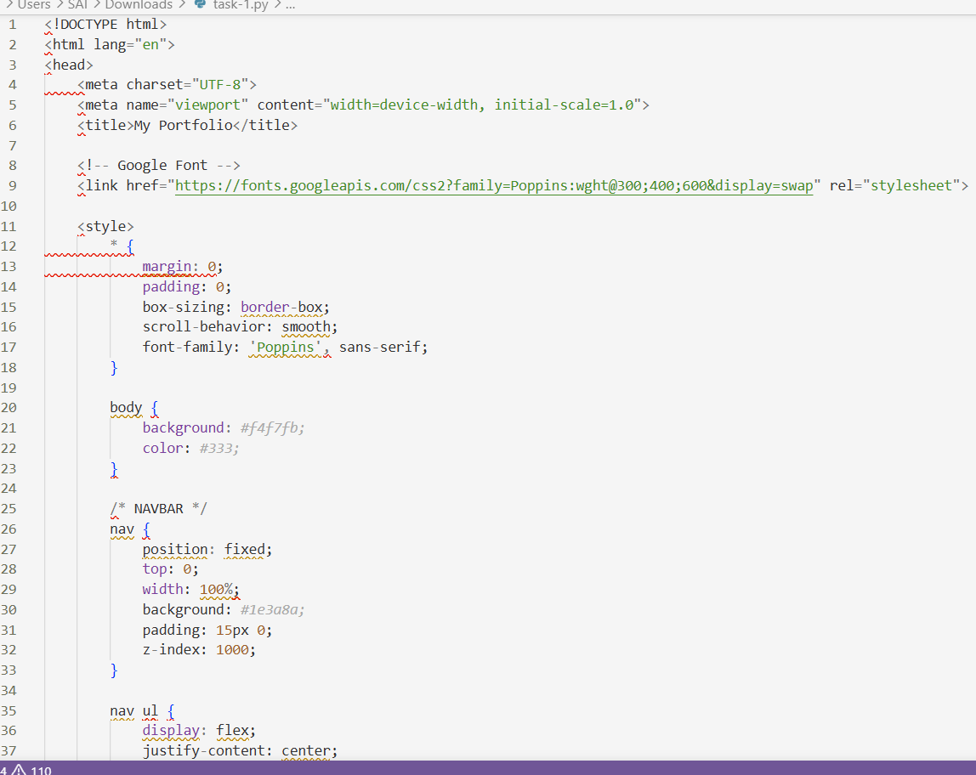
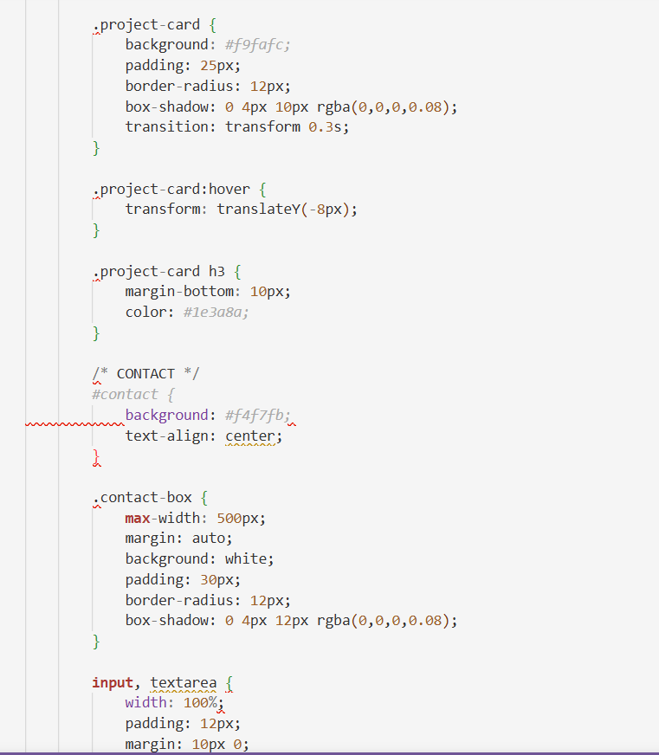
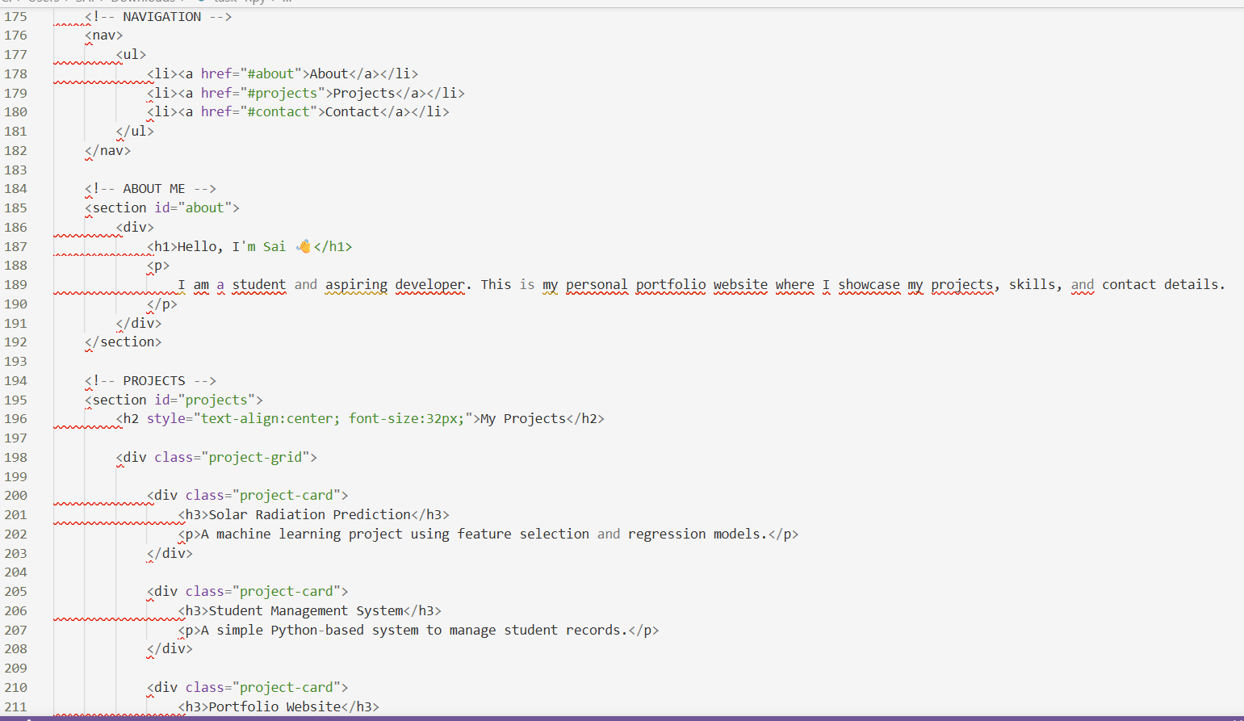

  - OUTPUT
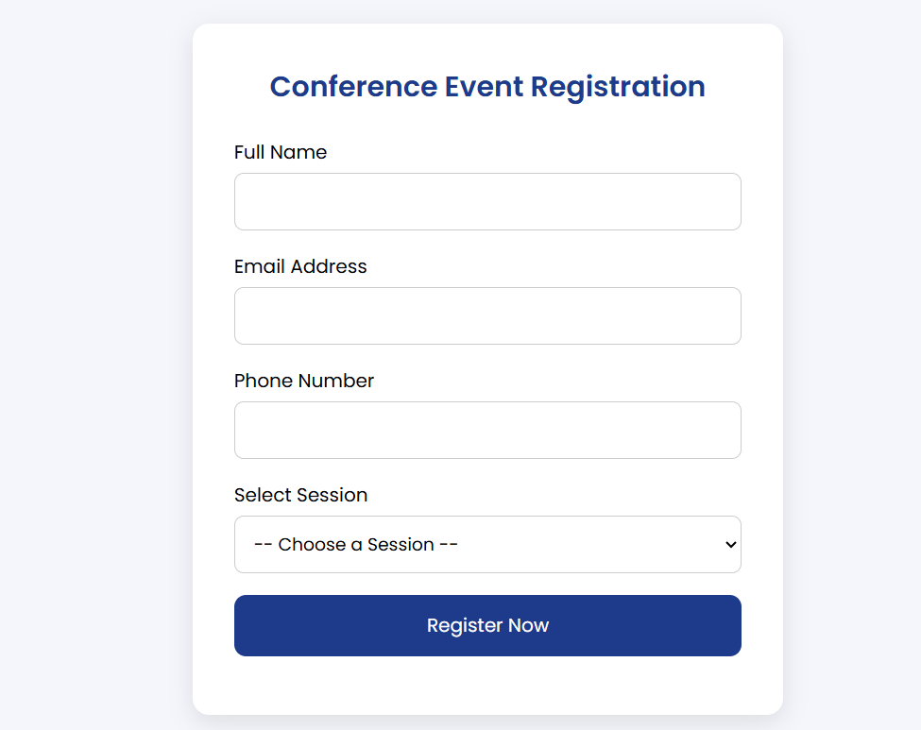
  - OBSERVATION
  - This task focuses on designing an event registration form for a conference using AI assistance. The form collects the user’s name, email address, phone number, and session selection. AI was used to implement JavaScript form validation to ensure that all fields are filled correctly. The form was also made accessible using proper labels and ARIA attributes to support screen readers.

  - Task 4 – Resume Website Build a one-page online resume. Requirements: • Sections: Profile Summary, Skills, Education, Experience. • Use AI to: o Propose professional typography styles. o Align sections using CSS Grid. o Add smooth scroll navigation between sections.
  - CODE
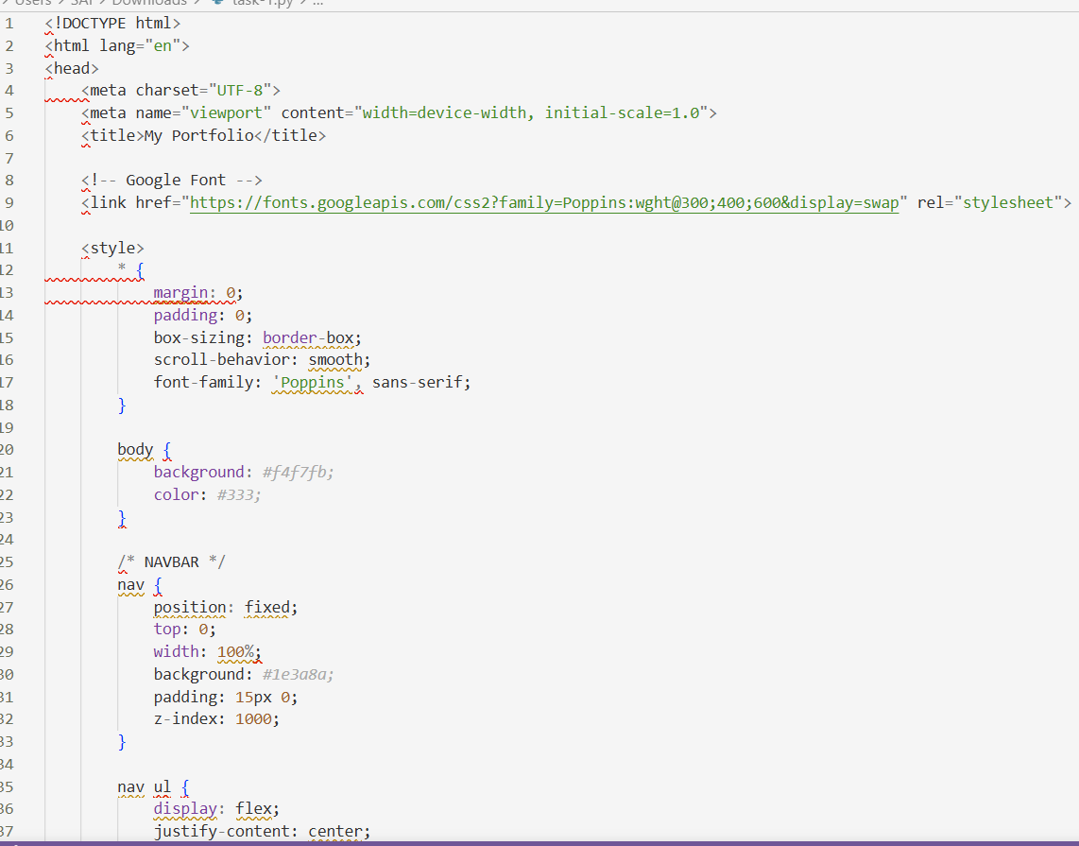
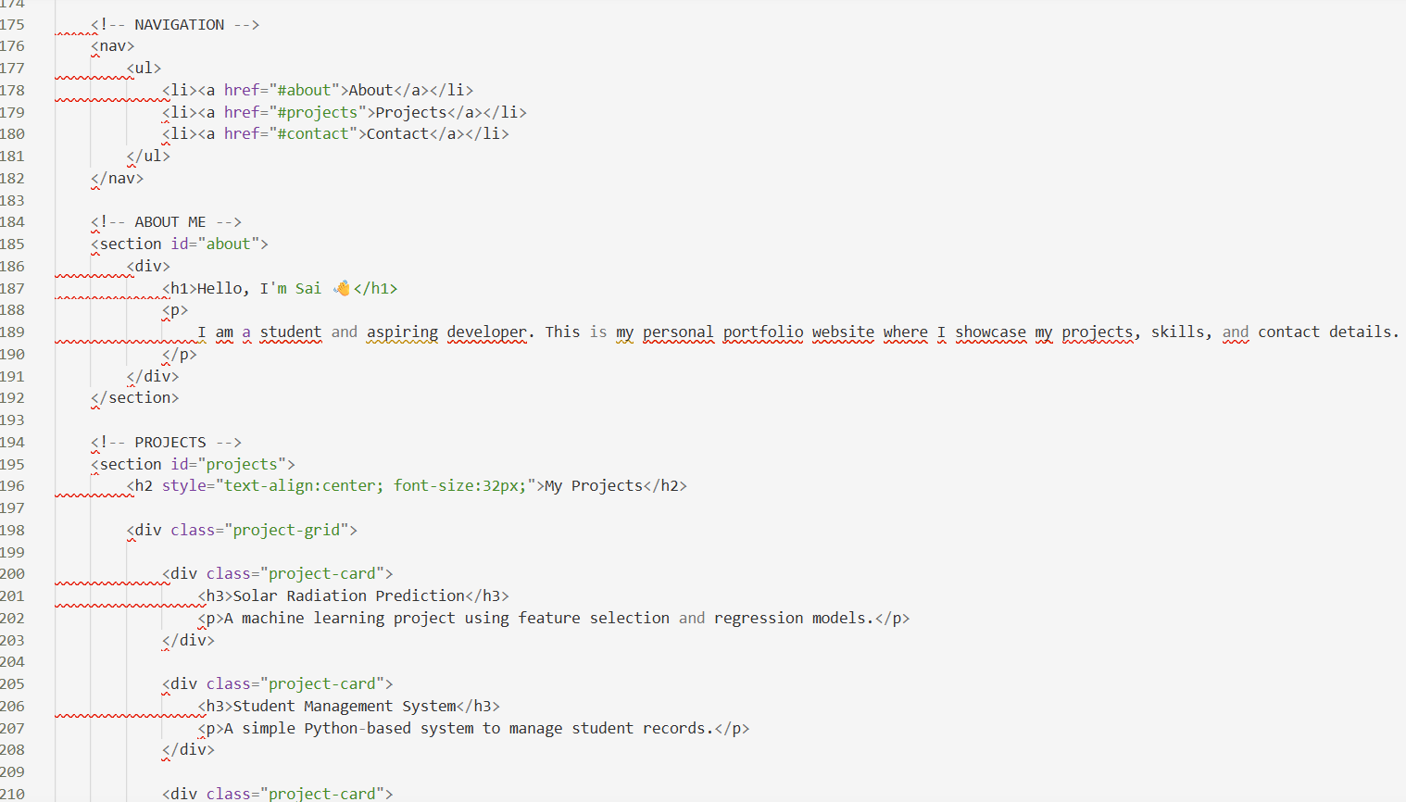

OUTPUT

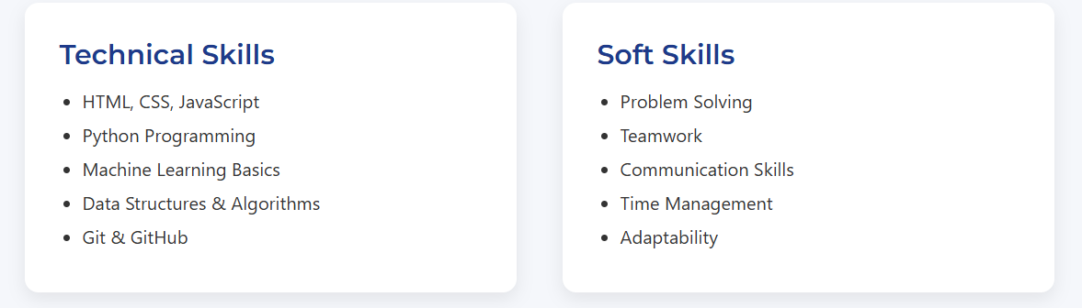

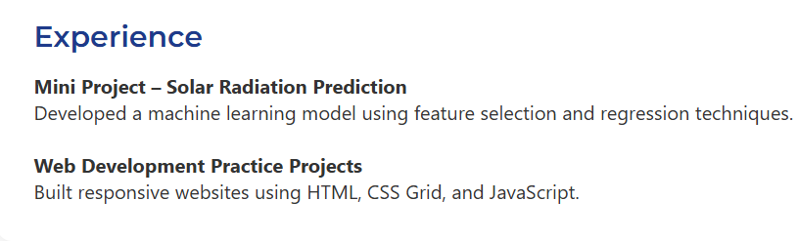
  - OSERVATION
  - This task focuses on building a one-page online resume using AI assistance. The website includes four sections: Profile Summary, Skills, Education, and Experience. AI was used to suggest professional typography styles such as Montserrat for headings and Roboto for body text. The layout was designed using CSS Grid to align the sections neatly, and smooth scrolling navigation was added to improve user experience.

  - Task 5 – Restaurant Menu Page Design a digital menu page for a restaurant.
  - Requirements:
  - • Display menu items with name, description, and price.
  - • Use AI to: o Suggest a food-friendly color palette.
  - o Design a responsive card-based layout. o Add hover effects on menu items.
  - CODE:
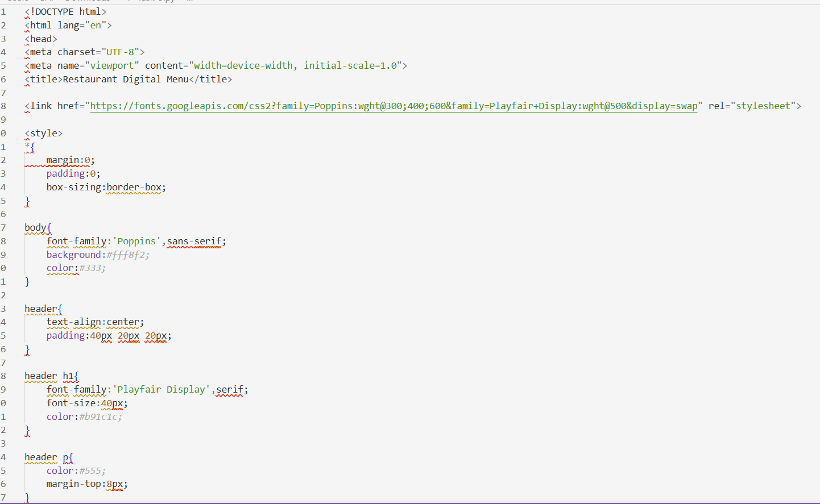
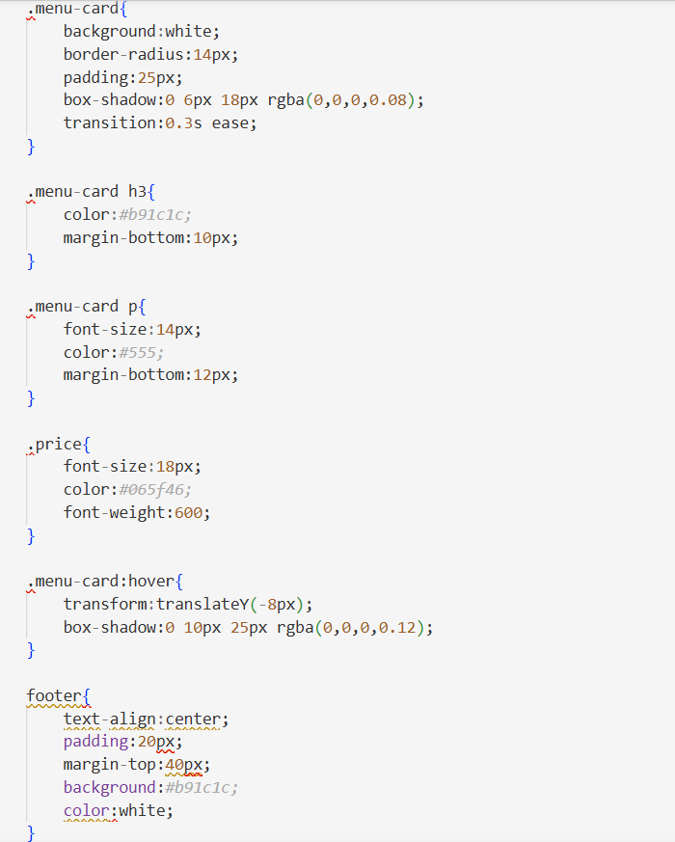
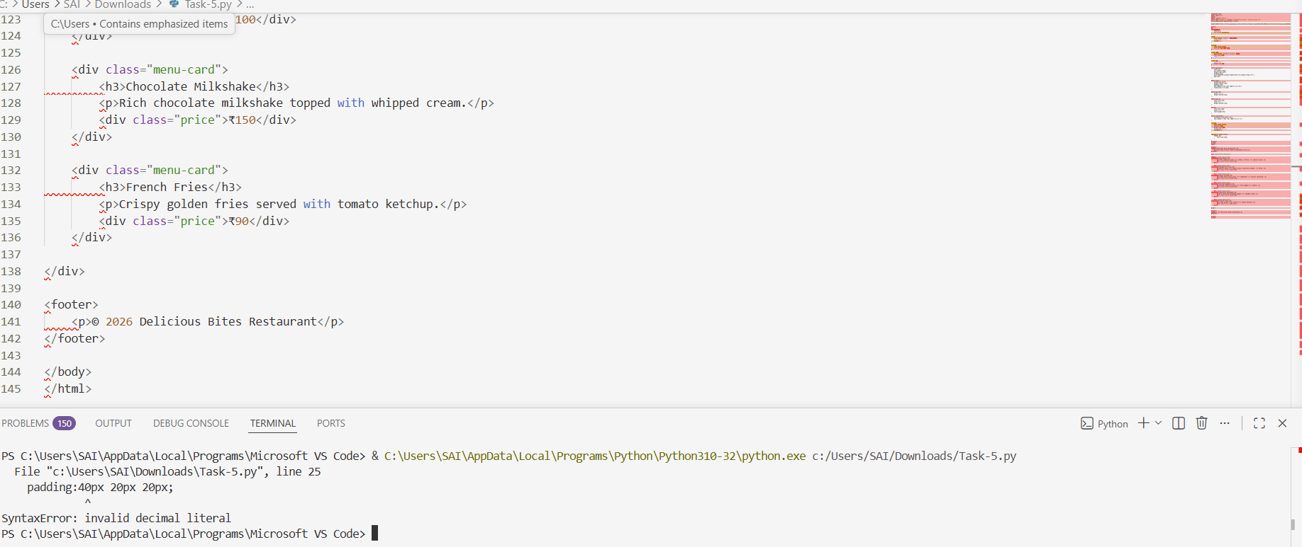
OUTPUT
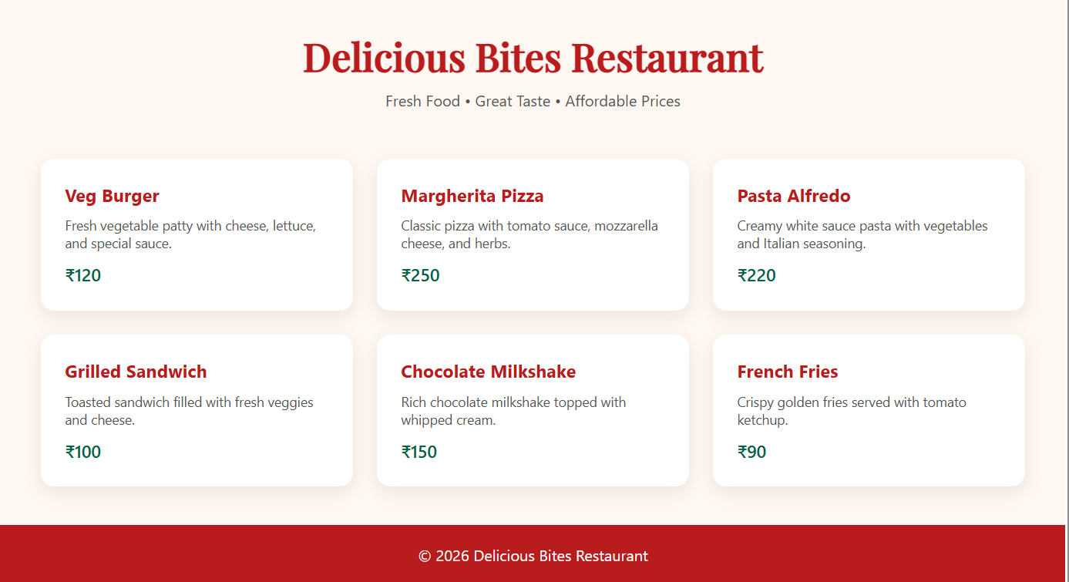
OSERVATION:
  - This task focuses on designing a digital menu page for a restaurant using AI assistance. The page displays menu items with their name, description, and price using a card-based layout. AI was used to suggest a food-friendly color palette with warm tones, design a responsive layout using CSS Grid, and add hover effects to improve the visual appearance. The final menu page is responsive, modern, and suitable for restaurant websites.

